
Understanding PAD & Keeping Nearby Fresh: Report (acp-confidential-cadoc)
December 2022 | Kelly Peterson Kevin Fu Meghan Desai Ishaan Kansal Jordan Caines Peter SergelJulia Kripke Research Brief

| Business Context & Research Questions: There are ~100M Cx US-wide that place <2 orders a month on DoorDash. These “Occasional Cx” represent a significant opportunity for growth for DD. One of the major issues with DoorDash identified is affordability, which is also a challenge for other Cx segments. Within the realm of affordability Cx noted high fees, and high total cost at checkout as some of the greatest contributing factors.

If we are able to increase these users OF, we can not only grow DD GMV, we can make the DashPass value prop more compelling for these Cx and convert them into long term retained / DP users. DoorDash first launched the EPIC test in Virginia Beach & Austin to introduce the concept of “total fees” for “nearby restaurants” which have lower fees. Now PAD tests are live which have “total fees” across all restaurants and distance based pricing associated with fees “Nearby” restaurants have lower fees than “further away restaurants”.
The overall goal of this research is to help understand the Cx awareness and perceptions of affordability as a results of total fees and distance based pricing:
- Are Cx aware of total fees? Do they understand it? Do they think it’s fair?
- Do Cx understand distance based pricing or that nearby restaurants have lower fees?
- How, if at all, did total fees change their ordering in the moment?
- How do they expect total fees to change their long term DoorDash behaviors?
- How do Cx feel about their nearby selection? Is anything missing?
- What negative impact might the total fee have on order frequency and/or perceived value?

Designs for reference: FIGMA

| Research Approach & Sample:
We fielded a 10 min survey online with N=1032 Cx who were exposed to PADv1 treatment within PAD test markets. Fielding allowed for natural fallout of converted vs. non-convert as well as DashPass status.

N=1031 total respondents
- n=914 converted vs. n=118 non-converted on most recent order
- n=708 DashPass Cx vs. N=324 non-DashPass

Additionally we spoke with N=5 Cx to follow up on their responses. This included both converted, non converted, DashPass and Classic Cx.

| TLDR Insights
- While Cx are aware of total fees, they are confused how they work, this is particularly DashPass Cx
  - In qualitative interviews, Cx who “take the time” to “look into it” had more positive sentiment around total fees
- The introduction of total fees AND distance based pricing at the same time has left some Cx confused of what is actually included, especially when some of their favorite further away restaurant fees have gone up
  - These Cx tend to think that we are “hiding new fees” or using total fees to “increase prices”
- Awareness that nearby=low total fees is limited
- High item prices continues to be a top driver of non-conversion along with higher perceived fees

| Recommendations
- Further in-app education is required around total fees
  - Include a post-order summary of what your fees would have been previously
  - Bold/color/highlight text that states that it includes both delivery & service fees
  - Test new language around the upfront transparency that total fees provides
- Need to make the “why” more clear for distance based elements
  - Additional education is required around why for Cx who regularly order from Rx that will now fall into further away to avoid them deciding to just order directly
- Provide additional education around exclusion of tax & tip so Cx do not feel surprised at checkout
- Show “example orders” that help illustrate how the total fee is the same or better for a typical DoorDash order (include things like an Rx name, items ordered, what fees were & what fees are)
- Consider excluding Cx from future tests that “frequent flyers”, one’s that use DoorDash for travel and are frequently changes addresses

| Detailed Insights
Overall awareness of “total fees” is fairly high with a significant higher level of awareness for Converted vs. Unconverted Cx. Non-converted Cx that were unaware of total fees were likely to call out
- Nothing is new
- Higher menu prices or
- Higher service fees when asked if there was anything new regarding the cost of DoorDash

There is also a notable difference in awareness among DashPass and non-DashPass Cx.

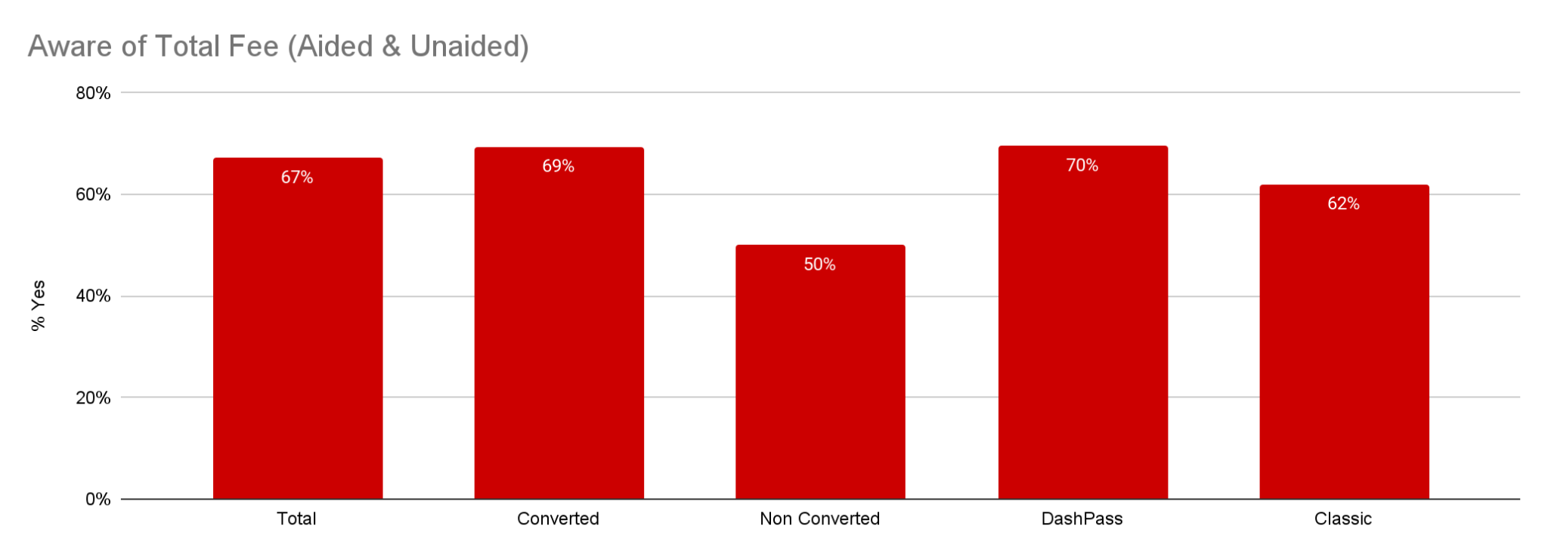
The vast majority of Cx have a range they expect to fall within when ordering from DoorDash. Cx who knew exactly how much they would spend on the order were significantly more likely to be aware of total fees (78% vs. 69%) because a change was more easily recognized. 52% of converted Cx felt they spent more than they originally planned.

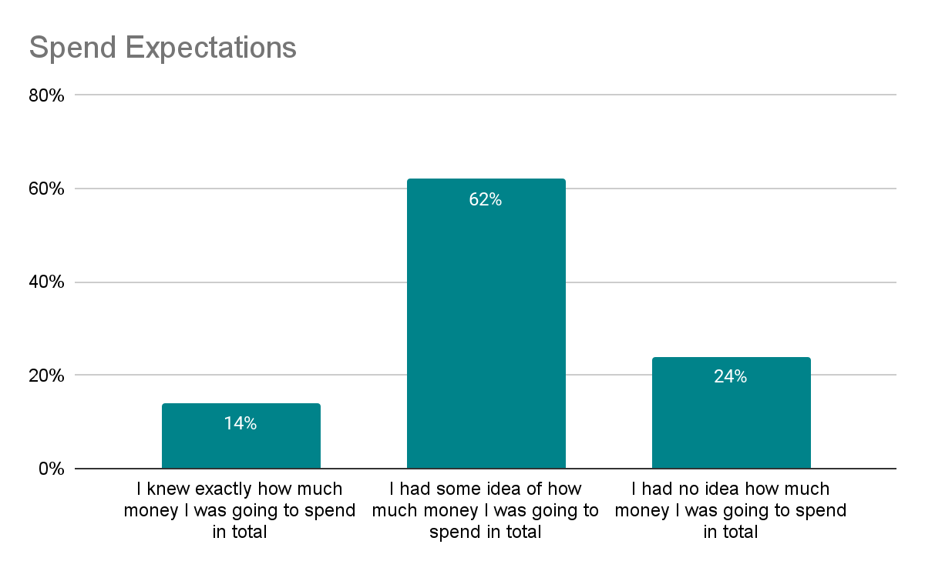
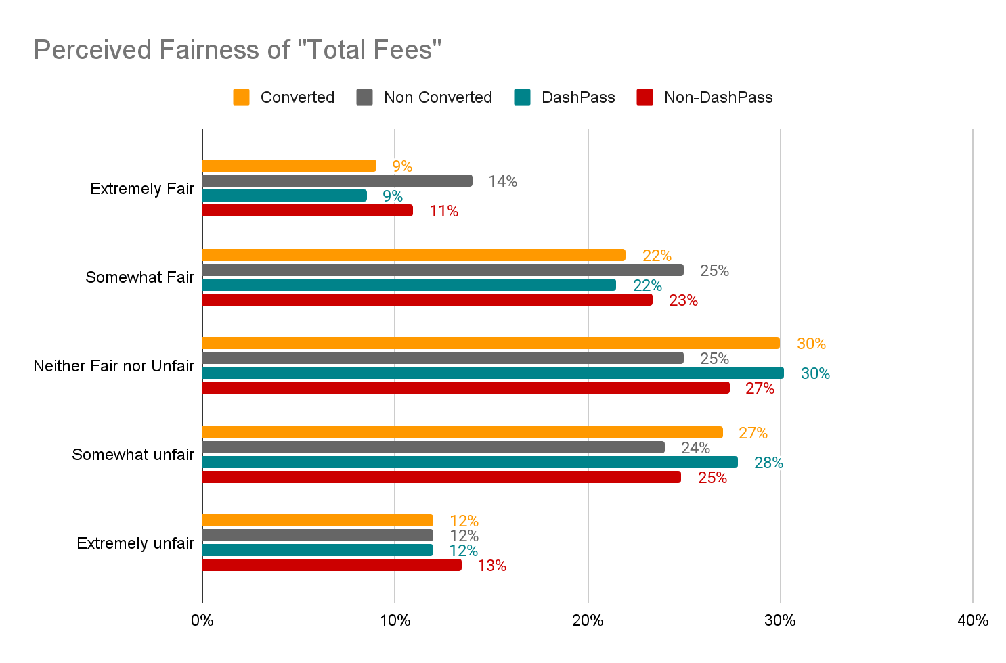

Interestingly, there is little difference in perceived fairness of the “total fee” between Converted status or DashPass status. Generally Cx are on the fence about how they feel about the fee in terms of fairness. Additionally there was no significant difference in perceived fairness among those that were single individual vs. multi-individual households, indicating Cx have not identified the value for larger subtotal orders. These results align with the overall Cx sentiment around “total fees” with one key difference, those who have DashPass view “Total Fees” significantly more negatively than those that do not have DashPass. Cx who were most confused about total fees in qualitative interviews were those that traveled and had different experiences around fees in the app recently. It is unclear it was linked to their geography and therefore they felt everything was constantly changing and that we were not being clear.

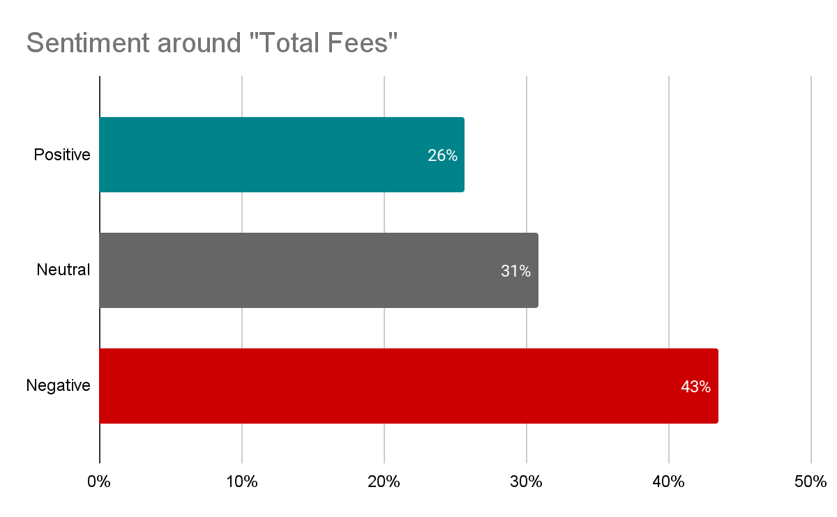

Negative Sentiment is driven by:
- DashPass Cx thinking they no longer have free delivery/we introduced a new fee to hide that they now pay for delivery
- Cx think this is an additive fee (on top of delivery and/or service fee)
- Cx are upset by the distance based element/ that some of their favorite restaurants now have higher fees because they are “further away”
- Cx are confused how it works, and therefore assume it will cost them more money
- Some Cx were surprised tip was not included
- Some thought “total fee” included the item subtotal and was upset that we would bucket everything at once
In their own words…
- “That I subscribe to Dashpass so I shouldn’t have to pay any fees.”
- “It is even more confusing, and it seems that the Dashpass is less beneficial than previously. That may or may not be the case, but that is how it appears.”
- “Long distance fees should be a lil lower if we’re already paying for service fees and delivery fees. I would order from further places but paying $25-40 for one item is a bit much.”
- “I didn’t realize it was a roll up fee , made me think it was a higher fee”
- “Appreciated it was upfront. Impacted the places I was interested in.”

Neutral Sentiment is driven by:
- Not paying attention to fees
- Feeling like they expect to see something for convenience
- Not caring about the structure of fees/I was hungry
In their own words…
- “Confusion but then I realized it wasn’t a big change overall”
- “Not concerned about how fees are listed as long as it is transparent what the costs are for”
- “No reaction, you pay for service.”

Positive Sentiment is driven by:
- Love of upfront transparency to select the best restaurant
- Simplicity of one fee
- Feeling that it is “faster”
In their own words…
- “Positive. Helped me to be able to plan for what my total would be.”
- “It makes it a little easier. I at least know how much I’m going to spend in fees instead of filling a cart and seeing a crazy amount of fees and then cancelling the order”
- “I appreciate the simplicity of not having several separate fees.”

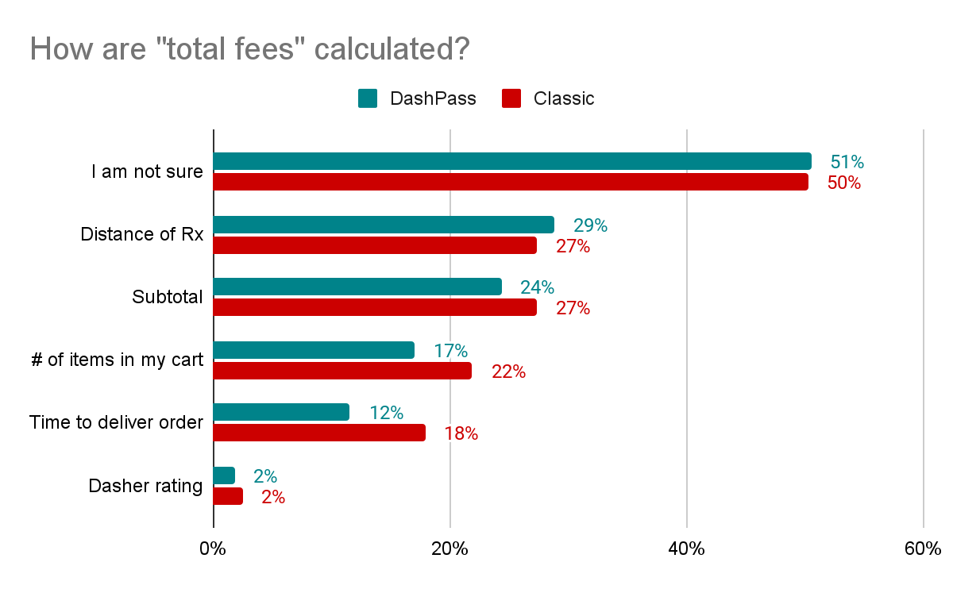
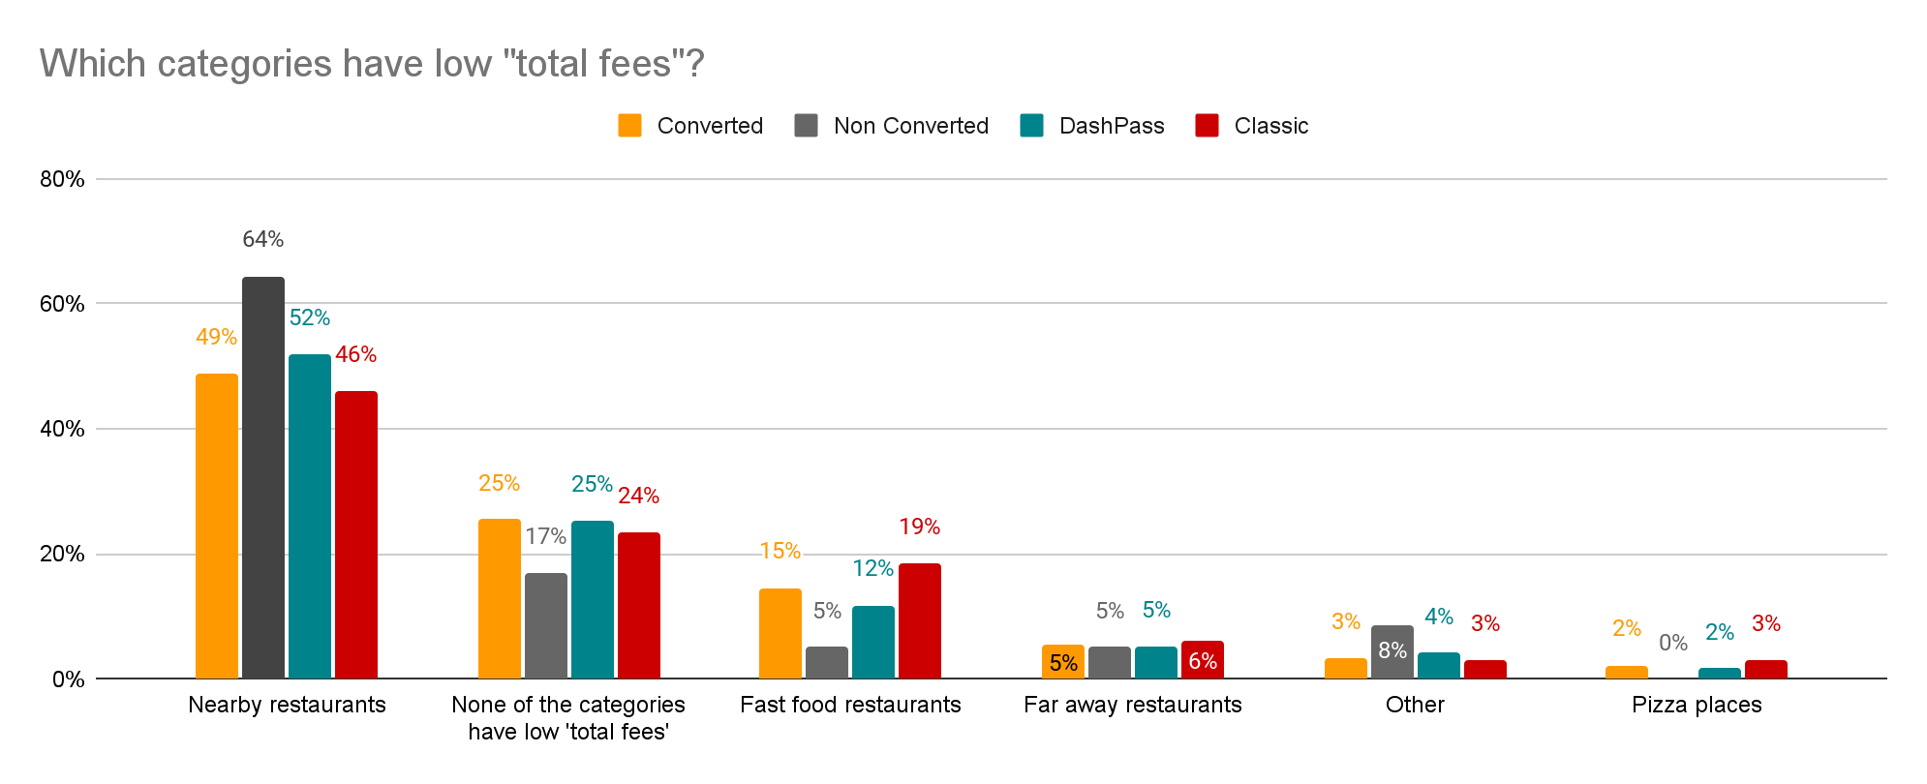

For those customers that did not convert, cost still played a large role in their reason not to complete their order. The #1 reason for non-conversion was that the prices are too item/item level inflation. In qualitative interviews Cx mentioned they specifically look at the price of each item when comparison shopping across apps.. Something may be just 30-50 cents cheaper on another app but it can add up.

The second most selected reason is that the fees are too high, which aligns to the sentiment that “total fees are higher”. This may partially be due to the fact that 19% of non-converted Cx knew the exact restaurant they were going to order from, which may be listed as a “further away” restaurant.

Reasons number three and four have to do with cheaper options or coupons on another app. 55% of Cx who selected this reason said they ended up placing their order through Uber, 28% said they placed their order directly through a Rx, only 8% selected GrubHub.

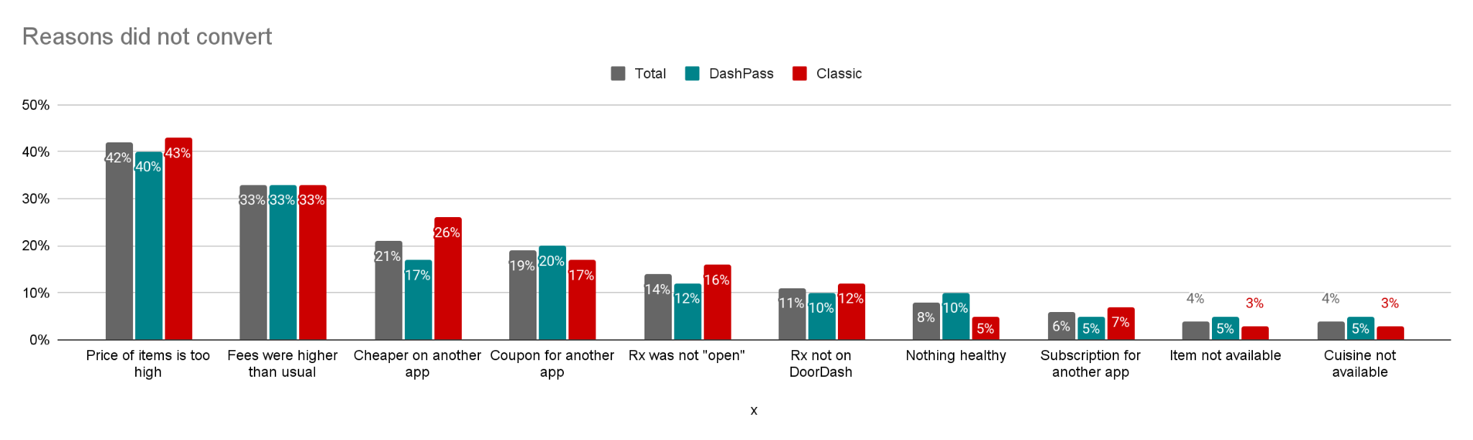

| Links
Full survey datatables
Notes from qualitative interviews

